#include <stdio.h>

# define SIZE 25
struct Stack {
int top;
int arr[SIZE];
};

void push(struct Stack *s);
void pop(struct Stack *s);
void display(struct Stack *s);

void main()
{
struct Stack s;
s.top = 0;
int a = 1;
while (a > 0) {
int i;
printf("1-Insert\n2-Delete\n3-Display\n4-Exit\n");
printf("Enter your choice: ");
scanf("%d", &i);
switch (i) {
case 1:
push(&s);
break;
case 2:
pop(&s);
break;
case 3:
display(&s);
break;
case 4:
return;
default:
printf("Invalid Choice\n");
break;
}
}
}

/***
Adds elements to the top of the stack
***/
void push(struct Stack *s)
{
int num;
// Checks if the stack is full
if (s->top < SIZE)
{
printf("Please enter the number: ");
scanf("%d", &num);
s->arr[s->top] = num;
s->top++;
}
else
{
printf("STACK IS FULL\n");
}
}

/***
Remove the last element from the stack
***/
void pop(struct Stack *s)
{
//Checks if the stack is not empty
if (s->top > 0)
{
s->top--;
s->arr[s->top] = 0;
}
else
{
printf("NO ELEMENTS IN STACK\n");
}
}
/***
Prints all the elements in the stack
***/
void display(struct Stack *s)
{
// Checks if the stack is empty
if (s-> top == 0)
{
printf("NO ELEMENTS IN STACK\n");
return;
}
for (int j = 0; j<s->top; j++)
{
printf("%d, " , s->arr[j]);
}
printf("\n");
}

Insert Function
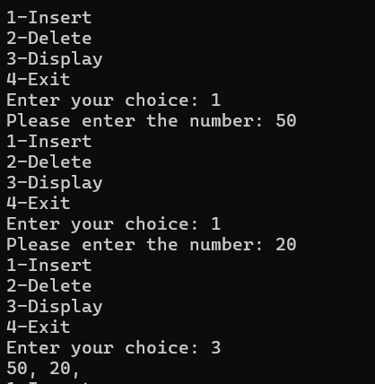
Delete Function
